**DATA ANALYSIS PROJECT**

**Unit Chair: Dr Musa Mammadov**

**Submission Date: 5:00PM Friday of Week 6**

**Table of Contents**

**Section 1: Introduction and Data Description** **2**

**Section 2: Exploratory Data Analysis and Results** **4**

**1. Data Cleansing** **4**

a. Find and correct errors in categorical variables 4

b. Count the total number of missing values for each column 5

c. Drop columns with more than 10% missing values 6

d. Drop rows with more than 20% missing values 7

e. Calculate z-score for numerical variables and replace outliers 7

f. Replace all missing values by implementing appropriate algorithms 7

**2. Main Structure and Key Variables** **7**

**3. Data Patterns** **7**

**4. Assumptions** **7**

**5. Visualization** **7**

**Section 3: Conclusion** **8**

**Section 4: References** **9**

**Dataset Name**: Rain in Australia

**Group Name**: Mon-13 (FANH) **On Campus/Cloud**: On Campus

|  |  |  |
| --- | --- | --- |
| **STUDENT ID** | **STUDENT FULL NAME** | **Individual contribution\*** |
| 218401269 | ALEXANDER PAK YU LAI |  |
| 218241616 | HARRY WILLIAM LODGE |  |
| 218459058 | VIET NAM NGUYEN |  |
| 218271795 | JARROD KENG YEN YONG |  |

**\*** 5 - Contributed significantly, attended all meetings

4 - Partial contribution, attended all meetings

3 - Partial contribution, attended few meetings

2 - No contribution, attended few meetings

1 - No contribution, did not attended any meetings

|  |
| --- |
| **Section 1: Introduction and Data Description** |

The Australian weather broadcast or the appropriate agencies comprehends the tomorrow weather, specifically whether it will be raining or not, to deliver updated weather news to citizens or propose proper plans for social activities respectively. Therefore, the dataset of day-to-day weather was collected across various stations over a period of 10 years. The observations extracted from the Australian weather dataset aim to return prediction of tomorrow rain by producing the possibilities of it or two binary labels (Yes and No, 1 and 0 in that order).

The “Rain in Australia” dataset consists of 24 variables in total. Among these variables, there are two variable types, categorical variable and numerical variable.

For the categorical variable, five variables are normal, including “Date”, “Location”, “WindGustDir”, “WindDir9am” and “WindDir3pm” while the remaining two binary variables are “RainToday” and “RainTomorrow”, especially “RainTomorrow” is a target variable. Also, these categorical variables are defined with nominal type. In addition, the “WindDir9am” and “WindGustDir” variables experience the biggest percentages of missing value with around 7 percent (Young 2017). Furthermore, the variable having the highest cardinality, which means that a variable has the largest number of labels, is “Date” with 3436 labels and the second is “Location” with 49.

For the numerical variable, there are seventeen variables, which refer to continuous type, namely “MinTemp”, “MaxTemp”, “Rainfall”, “Evaporation”, “Sunshine”, “WindGustSpeed”, “WindSpeed9am”, “WindSpeed3pm”, “Humidity9am”, “Humidity3pm”, “Pressure9am”, “Pressure3pm”, “Cloud9am”, “Cloud3pm”, “Temp9am”, “Temp3pm” and “RISK_MM”. According the figures in the table indicated the dataset provided by Young (2017), the variables witnessing the most missing values are “Evaporation” and “Sunshine” with roughly 43 and 48 percent respectively, followed by “Cloud9am” and “Cloud3pm” with nearly 38 and 40 percent in that order. Also, the “RISK_MM” variable is in consideration for dropping out of the dataset. According to Young (2017), this variable should be eliminated if it aims to train a classification model instead of regression one or the “RainTomorrow” variable is considered as a target because including this variable which indicates the further information of rain impacts negatively to the predicted values of the trained model or a lower accuracy score.

The observation about the “Rain in Australia” is that the method of training model to return a high accuracy score can be a regression algorithm instead of classification, but the null accuracy, where the accuracy is gained by preferring the most frequent value, should be compared with it to guarantee that the applied model results in the higher accuracy score. Another observation is that many pairs of variables would have strong or high correlation in the positive trend since they are intuitively correlated in terms of related fields of rain prediction.

Before the dataset is analyzed thoroughly and its comprehensive patterns are extracted, the dataset ensures to be evaluated carefully and cleaned to get rid of missing values or incorrect data by finding the frequency of null values for each variable, calculating z scores or exploring the inner problem of categorical and numerical variables. After finishing the process of data cleansing, the cleaned dataset should be tested, followed by discovering patterns which define relationships between variables due to their correlation coefficient. Eventually, the comprehensive analysis is finalized to sum up as well as conclude findings. Throughout the exploratory data analysis, the appropriate visualizations of data evaluation or results are illustrated.

|  |
| --- |
| **Section 2: Exploratory Data Analysis and Results** |

## **1. Data Cleansing**

To achieve a machine learning model with better performance and higher test accuracy score, the “Rain in Australia” dataset should be clean, which removes all missing values, known as null or nan, fixing incorrect data in terms of grammar or format and finding outliers. Therefore, the process of data cleansing is split up into six steps.

### **a. Find and correct errors in categorical variables**

The first stage of cleaning the dataset is to engineer errors in categorical variables, known as nominal columns. There are eight of them in total, “Date”, “Location”, “WindGustDir”, “WindDir9am”, “WinDir3pm”, “RainToday” and “RainTomorrow”, but the important variable scrutinized thoroughly during training and testing process is “RainTomorrow” since it is used as target to produce accuracy scores. Starting finding invalid date format in “Date” is the first step in eliminating errors in the categorical variables and the following function supported by the “datetime” library is applied on this variable to assess every single element.  
As a result, the “Date” column witnesses no incorrect value in regard to its standard format, e.g. “2008-12-01”. 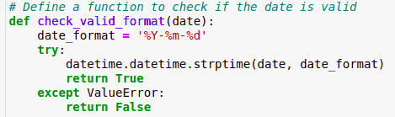

Focusing on the “Location” variable is the next categorical variable. To evaluate this column, all unique locations should be explored, and one small flaw on the dataset might be fixed. The small flaw is missing proper whitespace in some location names which contains two words. Therefore, the solution is simply that the whitespaces are placed appropriately in two-word locations. The lines of code below illustrates this approach.

However, this flaw in the “Location” column has insignificant impact on the dataset because the uniqueness of locations are still preserved. 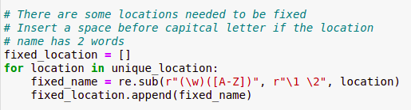

The next three categorical variables whose names are “WindGustDir”, “WindDir9am” and “WinDir3pm” are defined with sixteen compass directions including four caridnal directions, four intercardinal directions and eight secondary intercardinal directions. The fortunate results after processing them through some lines of code shows no incorrect directions in terms of format and the following figure indicates the typical checking.

The two remaining variables, “RainToday” and “RainTomorrow”, are represented by two unique elements, “Yes” and “No” which are two binary values and can be considered as 1 and 0 respectively. The positive results gained after these variables experience the validation process are no invalid data.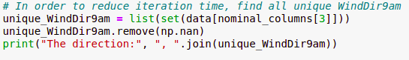

### **b. Count the total number of missing values for each column**

After the nominal columns finish being corrected, the total number of nan or null values of each column should be found, which becomes a base for the following steps. The below figure illustrates two functions which count the missing values and find their corresponding indices in columns.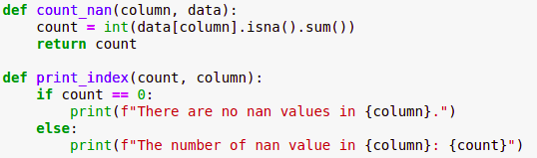

The following table gives information on the total number of missing values for each variable.

|  |  |
| --- | --- |
| **Variables** | **Total Missing Values** |
| Date | 0 |
| Location | 0 |
| MinTemp | 637 |
| MaxTemp | 322 |
| Rainfall | 1406 |
| Evaporation | 60843 |
| Sunshine | 67816 |
| WindGustDir | 9330 |
| WindGustSpeed | 9270 |
| WindDir9am | 10013 |
| WindDir3pm | 3778 |
| WindSpeed9am | 1348 |
| WindSpeed3pm | 2630 |
| Humidity9am | 1774 |
| Humidity3pm | 3610 |
| Pressure9am | 14014 |
| Pressure3pm | 13981 |
| Cloud9am | 53657 |
| Cloud3pm | 57094 |
| Temp9am | 904 |
| Temp3pm | 2726 |
| RainToday | 1406 |
| RISK_MM | 0 |
| RainTomorrow | 0 |

### 

### **c. Drop columns with more than 10% missing values**

Exploiting the result of the total number of missing values in the previous assists in calculating the variables having more than 10 percent nan or null data. Therefore, the percentages of missing values in these variables are easily computed by applying the lines of code in the following figure. 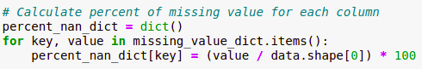

Consequently, there are four variables holding the percentage of missing values exceeding 10, “Evaporation”, “Sunshine”, “Cloud9am” and “Cloud3pm”, corresponding 44, 48, 48 and 40 percent, which encourages them to be dropped out of dataset by one function of pandas library, “pandas.DataFrame.drop”.

### **d. Drop rows with more than 20% missing values**

Removing the rows whose percentages of missing values are greater than 20 have the same strategy with the previous step. However, one more computation which leads to percentage calculation is counting the total number of missing values for each row by adding the following extra lines of code to figure it out.

The same process of computing the percentage of missing values with the prior step. However, the opposite results are achieved because of no rows with more than 20 percent nan or null data.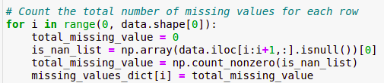

### **e. Calculate z-score for numerical variables and replace outliers**

### **f. Replace all missing values by implementing appropriate algorithms**

## **2. Main Structure and Key Variables**

Start from here

## **3. Data Patterns**

Start from here

## **4. Assumptions**

Start from here

## **5. Visualization**

Start from here

## 

|  |
| --- |
| **Section 3: Conclusion** |

|  |
| --- |
| **Section 4: References** |

Bureau of Meteorology n.d., *Note to accompany Daily Weather Observations*, Australian Government, retrieved 18 April 2020, <<http://www.bom.gov.au/climate/dwo/IDCJDW0000.shtml>>.

Young, J 2017, *Rain in Australia*, Kaggle, retrieved 18 April 2020, <<https://www.kaggle.com/jsphyg/weather-dataset-rattle-package>>.